Distributions Setup Guide
- Initiate a distribution

Go inside a Fund → Distributions → New Distribution → Fill the details → Save

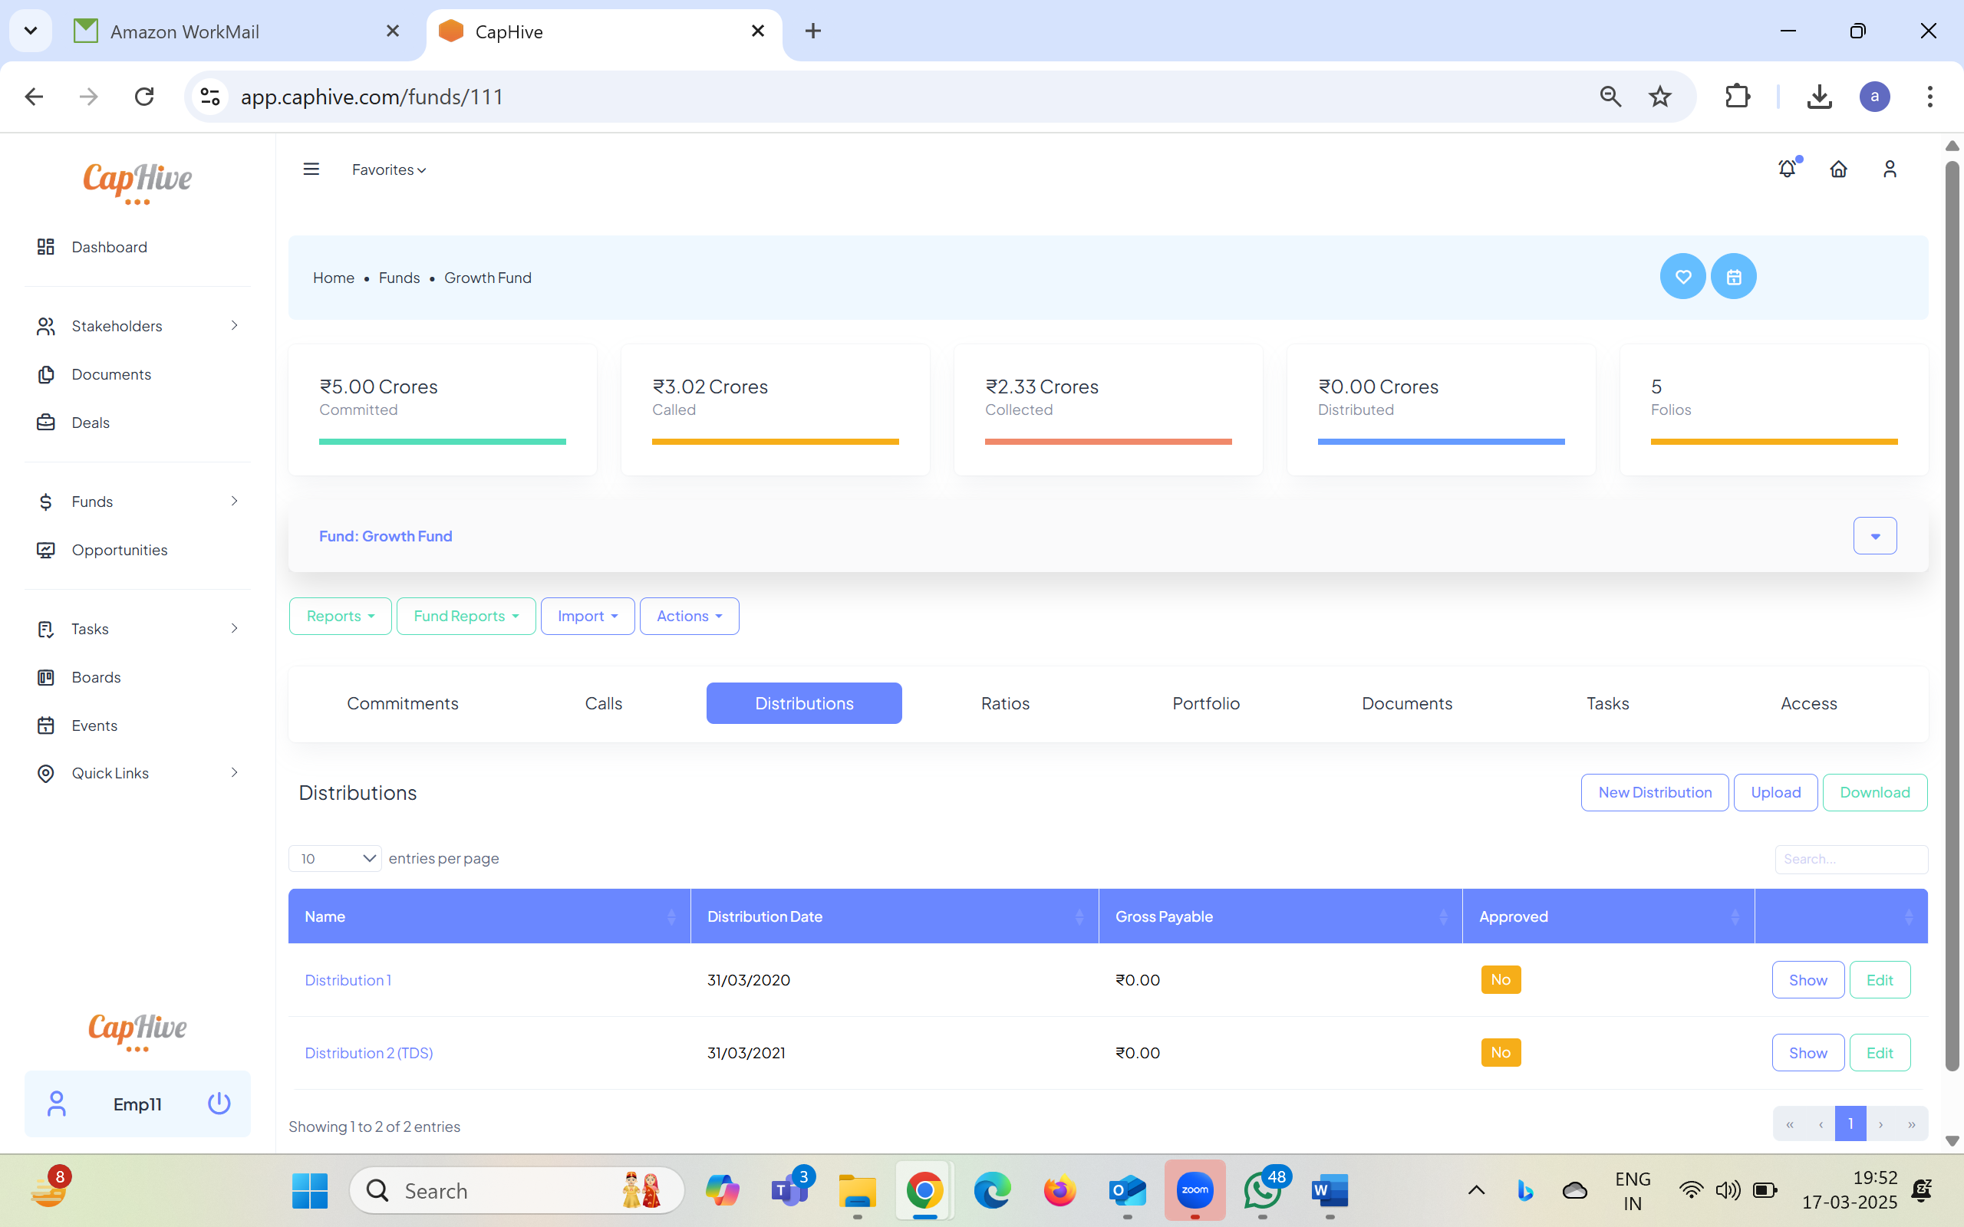

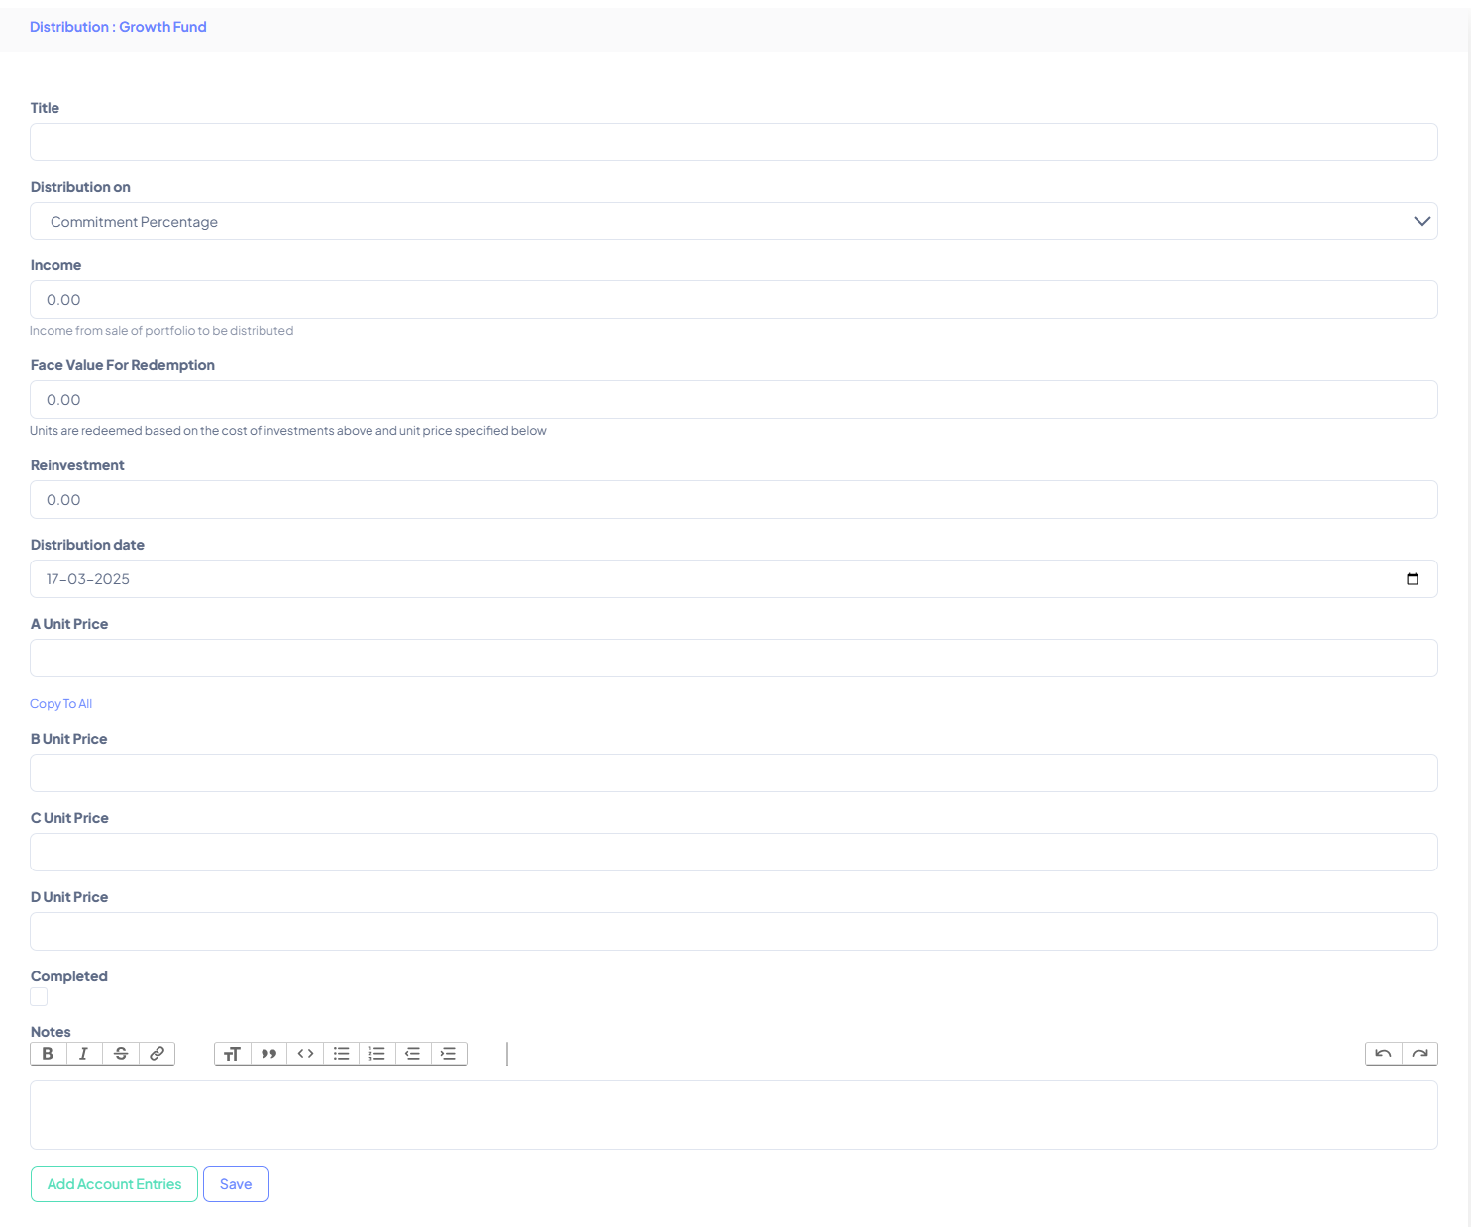

- Generate distributions payments based on commitment percentage, investable capital ratio, custom criteria, etc.
- Specify unit redemption price to track units on the platform. Units will be redeemed only towards amount for FV for redemption.
- Add multiple account entries and classify each account entry into income, FV for redemption, expenses, tax and reinvestment (expenses, tax and reinvestment will be reduced from gross payable to compute net payable). Folio wise account entries should exist within the date range to be considered for the distribution. The amount will be over and above the amount specified in the distribution.

- Distribution Payments and document generation

- Distribution Payments are auto-generated within seconds
- If the distribution basis is 'Upload,' distribution payments will have to be manually uploaded by clicking on ‘Upload’ button. This button will be enabled only if the distribution basis is ‘Upload’.
- Generate documents for all distribution payment with a standard template
- Can also set up a custom notification for the distribution payment
- Approve the distribution notices once generated

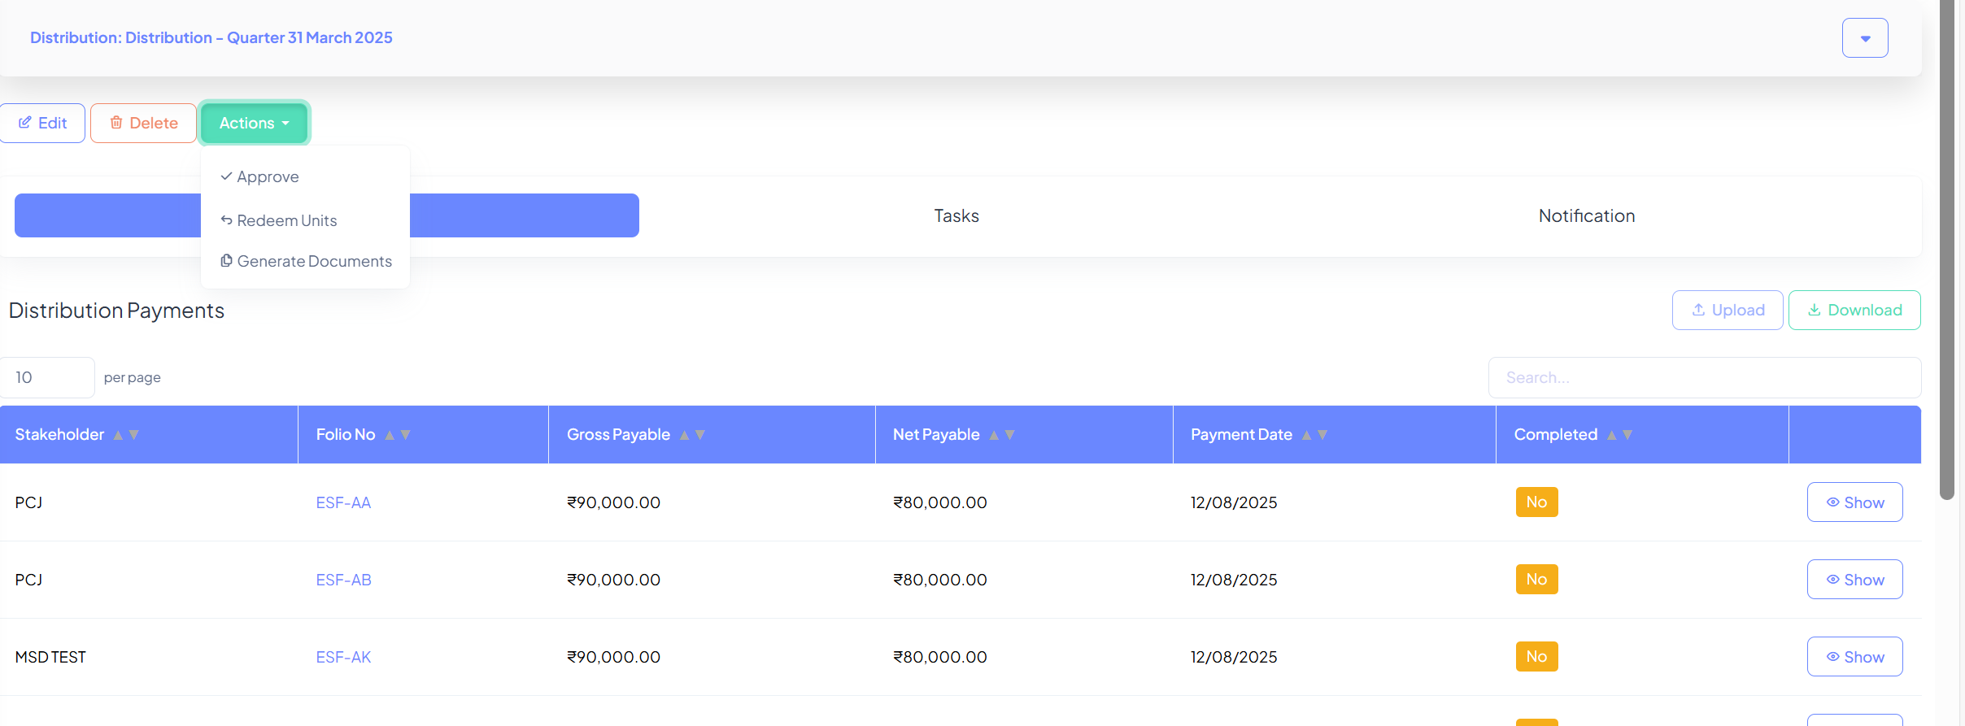

- Approve the Distribution

- ‘Approve’ the distribution once details are finalized
- Hit ‘Mark payments completed’ to trigger a notification once payments are made to the investor

